

GFWC JOPPATOWNE WOMAN’S CLUB, INC.

P.O. BOX 268
JOPPA, MD 21085
PETAL POWER
October 2011
“Powerful Women – Volunteering Hands of the Community”

Editor-in-Chief-Dottie Bishoff
Assisting Editor-Ruth Cameron
Federated April 1966
President’s Message Dottie Bishoff
443-402-1421
Dear Club Members:

I attended a very informative and educational meeting on September 20th. it was the State Board of Directors meeting held at the Breakers Hotel in Ocean City. This meeting was hosted by the Eastern Shore District. The community service program highlighted was Public Issues. All attendees were requested to bring a new pair of Women's pajamas for donation to the homeless shelter for Women Veterans, also Dress Barn had collected clothes for the shelter. We enjoyed a BINGO "FUN-raiser" to benefit the 2014 GFWC President's fund. A Minute-to-Win-it game was also played.
Ladies, it is not always work, we do have fun at these board meetings.

The speakers for the evening were Marian St. Clair, GFWC Treasurer, and George M. Hurley. Mr. Hurley's topic was the History of Maryland Military. Both speakers were very interesting.

Ladies you really need to come to the District and State Board of Director meetings, this is where you learn all about GFWC. I could tell you how I feel and what benefits I receive from these meetings, but you need to attend and find out for yourselves. I hope to see more of you at future meetings.

We will be starting a new seating arrangement for our general meetings at the Williamsburg Inn. The head table will of course stay the same. This new seating will help the new members get to know everyone and some of the other members will be able to catch up on any news they may have missed. When you enter the dining room the system will be explained to you.
All my best
Dottie

October Birthdays

10/01-Phyllis Hoover

10/06-Joyce Brown

10/19-Mitzi Drabik

Happy Birthday Ladies
Sunshine News:

Pete Murphy (Madeleine Murphy's husband) fell and broke his shoulder and is recuperating very nicely and is in no pain.

Barbara Ledford had plastic surgery performed on her left eye, on Monday September 19th., she is doing well, and was out and about the 3rd, day after her surgery.
(you just can't keep a good woman down)

Glad to see Sue Tyber at our meeting in September, she is still going to therapy and is in a little pain. She is also recovering from eye cataract surgery she had in July and August.

If anyone is ever in need to borrow a wheel chair call Dee Martin or Joyce Brown.



Conservation
Jeanette Petnic-410-679-0959

Keep the bay water clean, fishable and swimmable. This was the requirement of the Clean Water Act, passed in the 1970's. Unfortunately our local waters aren't clean. We are partly to blame. We need to stop over fertilizing our lawns, wasting water and causing trash to reach our creeks and streams. It is our responsibility to do our share in
"Cleaning Up The Bay" More information to come next month.

Bedding and dog food was taken to the Humane Society.

The aluminum tabs are adding up again.

I am still collecting used eyeglasses and old cell phone.

KEEP UP THE GOOD WORK!!!!!!

Education;
Barbara Ledford
420-679-1166

We began our new woman's club year off to a good start. Our hero reading group started this week with great enthusiasm, hopefully it will remain this way all year. Our new readers were able to meet Ms. Constantine, she gave us a little get-together party last Friday.

Hope everyone had a nice summer and stays healthy all year.

Finance
Ways & Means
Rosemarie Sebula-410-679-3357
Rose Mary Vaccaro-410-679-8801

Hi Ladies,
This year we will have a tea, bus trips, candy sales and a possible raffle to help make our budget. We look forward to all our members participating in all our planned fundraisers.

REDNERS receipts are a great way to help us, so keep them coming and don't forget to keep the receipt whole, please DO NOT cut any part of the receipt off. See you at the September meeting.

Home Life
Barbara Albers-410-679-5260

We are excited about the walk to End Alzheimer's . Thank you for your support! We plan to make you proud.

Our Habitat for Humanity basket is prepared and we are waiting for the new date for the home dedication.

Anna's House has given us a short list for their needs, and we'll get on it after the big "walk".

The date for the Brunch with Santa is Dec, 10th. so mark your calendar.

Public Issues:
Lori Eck
443-484-2054

We have a bag of clothes to deliver to the homeless women shelter. Dottie and I will be delivering them soon. .

We will be having a speaker at our meeting in October concerning the homeless war
Veterans.

Committee meeting at my house on October 25th. 7:00 p.m. I have some great ideas, please bring any ideas you may have concerning Public Issues or the homeless. .

Art Community Service Program

Loretta Di Loreto- 410-679-2259

One of the club members suggested photography this year for the committee to pursue, so I called my photographer friend David Gigiliotti,, who is really on of the best wild life photographers in the states to see if he could help us and I found that he gives workshops at our local Anita C. Leight Estuary Center once a month. Check these out.

Fall Foliage & Feather Fotos-Saturday, Oct. 22, 10:00 a.m. thru 12:00 p.m.

Photograph the beauty of Fall at the Estuary Center. The leaves will be fiery and birds active, so dust off your camera and capture some colorful images of this transitional season.

Holiday Creations with Photoshop Elements-Sunday, Nov. 13, 1:00 pm-4:00 p.m.

Learn to make holiday cards and t-shirts from you own photos, create seasonal frames and borders, add text, adjust lighting and color, and other helpful holiday skills in Adobe Photoshop Elements..

Please talk this up among yourselves and, if interestedc call the center at 410-612-1688 to register.
I will be coming home from the Deep SouthNew Orleans)) October 22, so you have to do this yourselves, but this is a beautiful time of the year to be out taking pictures.

HAVE FUN!!!

International Outreach Community Service Program

Diane Raycob-410-893-7534
Betty Meidinger-443-922-7706

Please observe World Food Day Sunday October 16. On this day, you are encouraged to eat no meat. Believe me, you and your family will survive for one day without meat
World Food Day is a world wide event designed to increase awareness, understanding and informed, year-round action to alleviate hunger.

Here is a great burrito recipe:

Ingredients:

- 1 (8 ounce ) box red beans and rice mix (such as Zatarains )
- 8 (10 inch) whole wheat tortillas
- 1/2 cup sour cream
- 1 cup shredded cheddar cheese
- 4 teaspoons Creole seasoning ( such as Tony Chachere's)

Directions:

- Cook rice as instructed on package. Place tortillas in microwave and heat on high for 10 seconds.

- Spoon 1/4 cup rice and beans down the center of each tortilla. Top each with 1tablespoon sour cream., 2 tablespoons cheddar cheese and 1/2 teaspoon Creole seasoning. Fold edges over to enclose filling.

NUTRITIONAL INFORMATION;

Amount per serving: Calories: 201--Total fat: 9.4g. Cholesterol: 24 mg,
Powered by ESHA Nutrient Database

2nd Vice-Presidents report- At the October general meeting, we will have a program concerning the homeless war veterans.
If you have any idea for our December program, please let me know.

Also, we hope to get the UNICEF collection boxes in time for Halloween..

Hospitality: Hostesses;
Madeleine Murphy- 410-569-0477
Loretta DiLoreto-410-679-2259
Stuffed Flounder
Chicken Parmesan
Plain Chicken Lori Eck-443-484-2054

Dinners are $20.00 except for crab cakes which are $25.00, and Prime Rib, which is $25.00. Please remember to call the hostesses the Tuesday before the scheduled meeting date to place your order. If you are bringing a guest, give the hostess her name and order.
Do not call the restaurant!!! If something comes up and you cannot make the meeting and do not cancel your order, you are responsible for the cost of the meal.

DATES TO REMEMBER:

Oct. 3- Finance/Fundraising meeting, Rosemary Sebula's home 7:00 p.m.

Oct. 6-District BOD meeting, Mia Carolina Restaurant, Glyndon, MD

Oct. 13- General Meeting Williamsburg Inn, 7:00 p.m.

Oct. 25- Public Issues meeting at Lori Eck's Home 7:00 p.m.

Oct. 27 -Executive Meeting Jeanette Petnic's home 7:00 p.m.


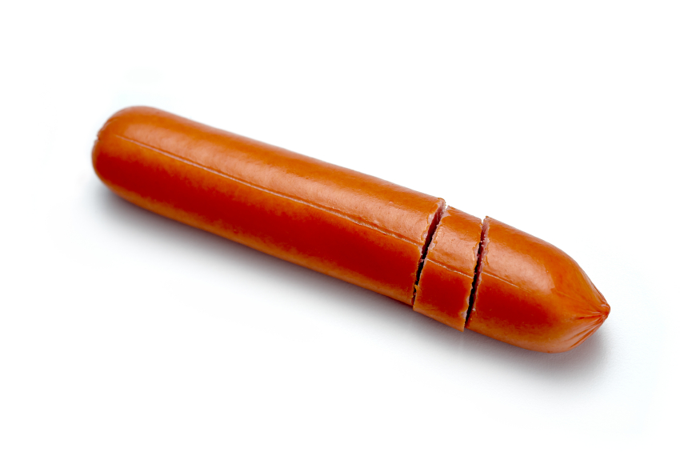

Hot Swiss Cheese Dip-Compliments of Angie Haines/Myrtle Club

Ingredients:

8 oz. cream cheese
1 1/2 cup shredded white swiss cheese
3/4 cup Miracle Whip Mayonnaise
8 slices bacon (fried and crumbled)

Mix first 3 ingredients well and put in glass baking dish. Spread crumbled bacon over the cheese. Bake 20 minutes in 350 degrees oven . Serve with crackers.

Bourbon Hot Dogs-Compliments of Angie Haines/Myrtle Club

1 pkg. hot dogs (cooked and cut into bite size pieces)

1 cup lt. brown sugar
1 cup catsup
1 cup bourbon
Stir well and cook slowly until sauce thickens then add hot dogs..
ARE YOU SMARTER THAN A 60 YEAR OLD!!!
ANSWERS:

01. After the Lone Ranger saved the day and rode off into the sunset, the grateful citizens would ask, who was that masked man?
Invariably someone would answer, I don't know, but he left this behind. What did he leave behind? Silver Bullet

02. When the Beatles first came to the U.S. in early 1964, we all watched them on The Ed Sullivan Show.

03. Get your kicks, on Route 66.

04. The story you are about to see is true. The names have been changed to protect the innocent.

05. In the jungle the mighty jungle the lion sleeps tonight.

06. After the Twist, the mashed Potato, and the Watusi, we 'danced under a stick that was lowered as low as we could go in a dance called the limbo.

07. Nestle's makes the very best_chocolate.

08. Satchmo was America's Ambassador of Goodwill. Our parents shared this great jazz trumpet player with us.
His name was Louis Armstrong_________________.

09. What takes a licking and keeps on ticking:?
_Timex Watch___________________.

10. Red Skeleton's hobo character was named _Freddy the Feeloader and Red always ended his television show by saying
"Good Night, and God Bless_____________________.
11. Some Americans who protested the Vietnam War did so by burning their draft cards (Bras were also burned but not the American flag as some have guessed)

12. The cute little car with the engine in the back and the trunk in the front was call the VW. What other names did it go by?
__Beetle__&__The Bug___________.

13. In 1971, singer Don MacLean sang a song about, "the day the music died'. This was a tribute to _Buddy Holly____________.

14. We can remember the first satellite placed into orbit. The Russians did it. It was called__Sputnik_____________________.

15. One of the big fads of the late 50's and 60's was a large plastic ring that we twirled around our waist. It was called the_Hula Hoop__________.

THINK POSITIVE
I AM!!

I CAN!!

I WILL!!

I MUST!!

HAPPY HALLOWEEN

